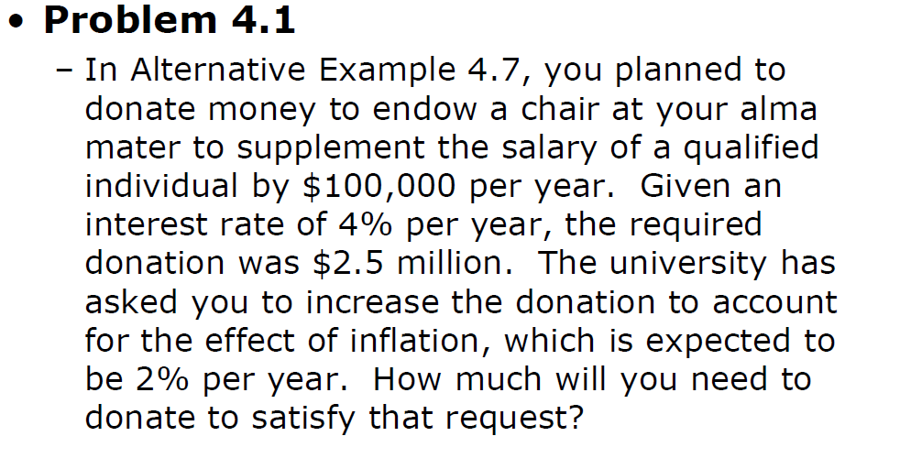

PV(growing perpetunity) = $\frac{\$100,000}{0.04-0.02}$ = $5 million

So, donate $2.5 million more.

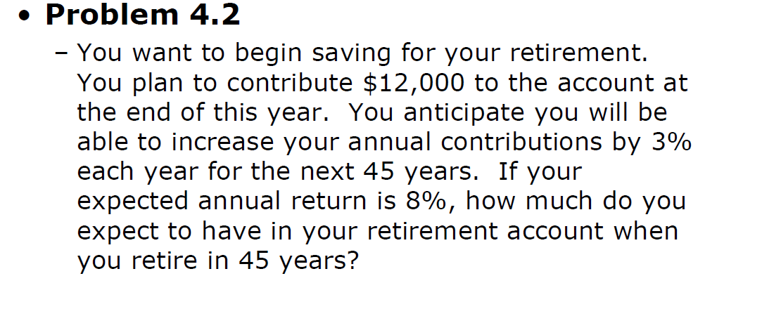

Annual return = 8% , the amount of money putting in each year increases by 3%.

$\sum_{0}^{45}{\$12,000*{\left(1.03\right)}^{i}*{(1.08)}^{45-i}}$ = $\frac{12,000*{1.08}^{45}*(1-{(\frac{1.03}{1.08})}^{45}}{1-\frac{1.03}{1.08}}$ = $277,395.36

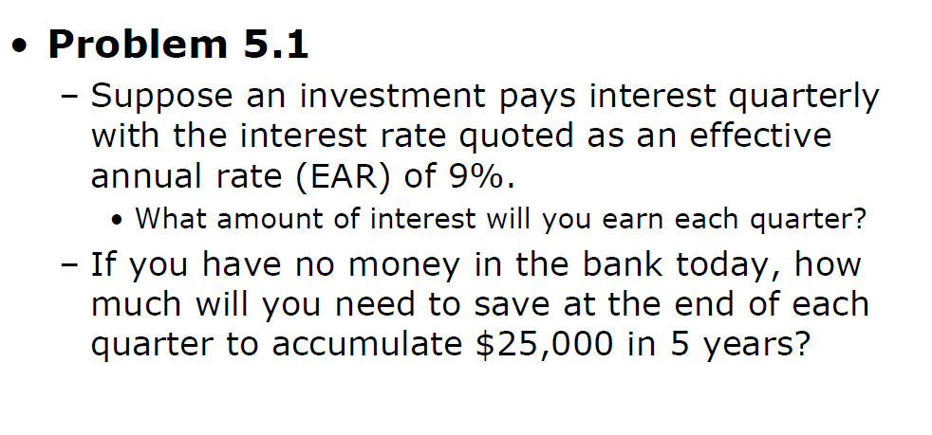

Quarterly interest rate = ${(1.09)}^{\frac{1}{4}}$ = 1.0218 = 2.18%

$25,000 = $X* \frac{({1.0218}^{5*4}-1)}{(1.0218- 1)}$

∴ X = $1,010.82

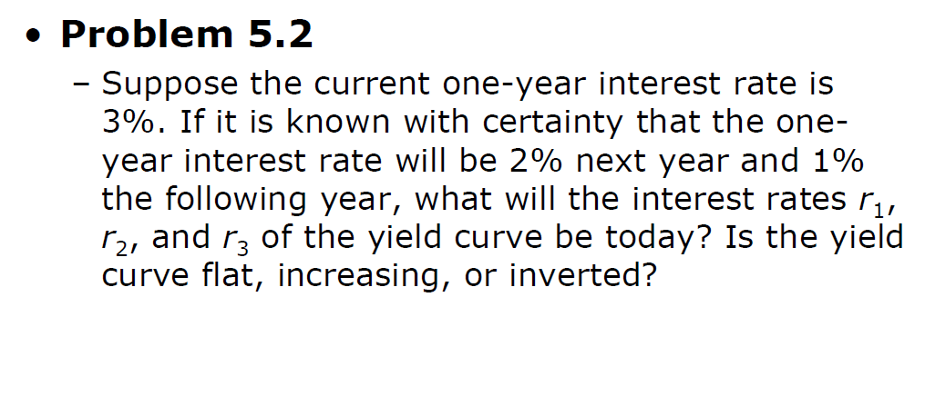

Inverted, ∵ interest rate is decreased, 3% -> 2% -> 1%.

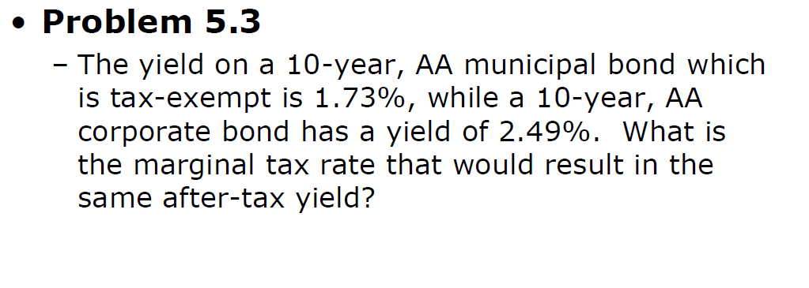

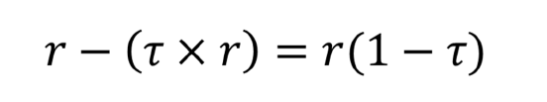

∴ 1.73% = 2.49%(1-t),

t = 0.69%